FAST® Engine Transplant Kits for Ford Coyote Engines

Memphis, TN – FAST® has assembled an easy-to-install engine control package for Ford Coyote engine transplants.

Ideal for anyone wanting to swap a modern Ford Coyote engine into a classic muscle car or street rod, the FAST® Engine Transplant Kit includes a fully-tunable XFI Sportsman™ ECU, XIM™ ignition module, Valve Timing Control module, complete engine wire harness and a Coyote-specific Big Mouth® LT 87mm cable-driven throttle body.

Unlike other systems on the market that require you to convert over to a complicated throttle-by-wire accelerator pedal assembly, the FAST® kit allows you to retain your original car’s cable-style factory pedal assembly. This makes for a much easier kit installation, plus you will enjoy the benefit of better throttle response and a more “connected” feel to the engine’s power.

For applications using aftermarket stack-type induction systems, a kit without the throttle body is also available.

Quick Facts

Product: FAST® Engine Transplant Kit for Ford Coyote Engines
Part Numbers: #303006 (w/ throttle body), #303007 (w/o throttle body)
Street Price: $2,699.95 - $2,999.95

Social Media Pitch: The FAST® Engine Transplant Kit is a complete engine control package for swapping a Coyote engine into a muscle car or street rod

Features & Benefits:
- Keep your original car’s factory cable-style accelerator pedal assembly
- Simple control of VVT, with no camshaft phaser modifications needed
- Includes ECU, tuning software, ignition and Valve Timing Control modules, cable throttle body and all sensors and wiring
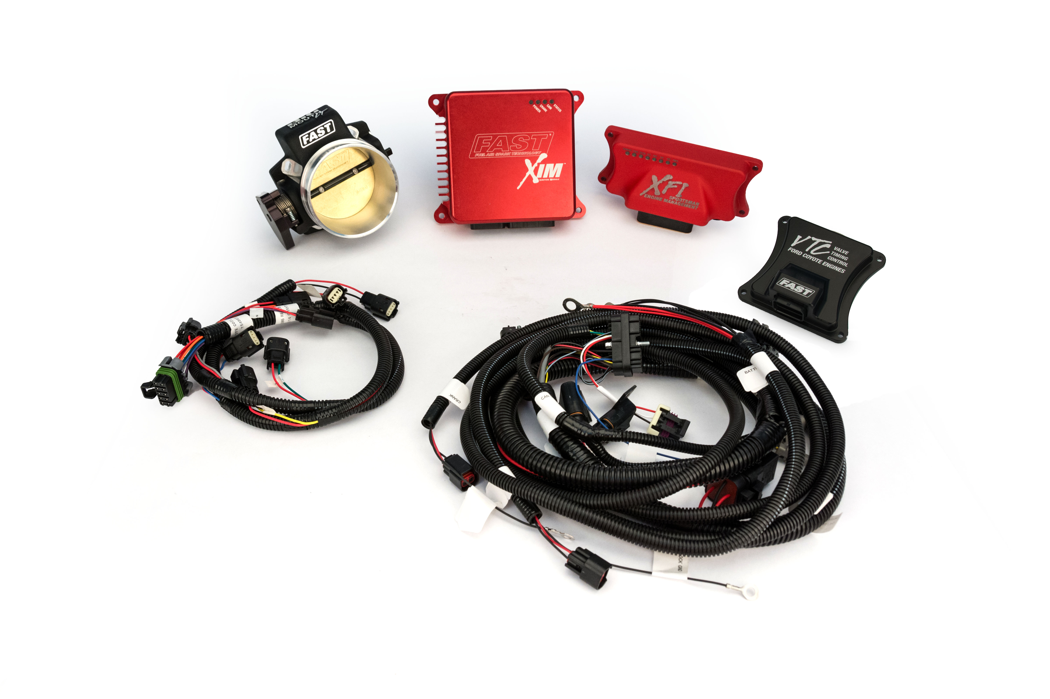

About FAST®

Since 2001, FAST® has been a recognized leader in advanced EFI technology. Now, not only does FAST® offer the components to adapt virtually any engine to fuel injection, it is also an emerging force in the ignition market. With the latest in easy-to-use electronic components, the experts at FAST® have everything you need to make high-tech horsepower. Additional information about FAST® and its products can be found at www.fuelairspark.com or at 1.877.334.8355. Also visit us on Facebook at facebook.com/FASTWins, on Twitter at twitter.com/FASTEFI or on YouTube at CPGNationTV.com.

Media Contact: Cindy Bullion, cbullion@compcams.com, 901.795.2400 ext. 1643

